Theme-Custom

|  |  |  |  |  |  |  |  |
| --- | --- | --- | --- | --- | --- | --- | --- |
| Pages in Banner form | | | | | | | |
| Home | Parent  Authorities  Central Legislature  State Legislature  Government State Government  Supreme The Court of India  The High Court of ----------------  The Court ------------------------ of ------------------  Other Authorities | Child  Documents  Central Act  ---------------Act Government of India  Government of ----------  Rule  Regulation  Notification  Promulgation  Statutory Rules and Orders  Government Orders  Statements  Press Releases  Circulars  Memorandums  Guidelines  Orders  Letters  Judgments  Decrees and Orders  Warrants  Notices | Discussion Forum | Articles | FAQs | About us | Contact us |
| Widgets | | | | | | | |
| Categories | Recent Posts | Comments | Search | Archives |  |  |  |
|  |  |  |  |  |  |  |  |
|  |  |  |  |  |  |  |  |
|  |  |  |  |  |  |  |  |
|  |  |  |  |  |  |  |  |
|  |  |  |  |  |  |  |  |
|  |  |  |  |  |  |  |  |

Dynamic Scroll

Those who are in possession of rare, relevant orders, circulars , Acts, Rules, Judgments and similar material and are interested in sharing and preserving them for posterity may scan and forward them in PDF format along with their full address for communication (inclusive of email ID and mobile number ) in the email ID given below. Their address shall be posted in the blog/website for the information of the needy to contact.

Data Entry Form

|  |  |  |
| --- | --- | --- |
| Document Number | |  |
| Date of Document | |  |
| Name of Authority | |  |
| Name of Document | |  |
| Relevant Section or Rule Numbers | |  |
| Synopsis in English | |  |
| Subject in English | |  |
| Typed text in English or Malayalam, as the case may be. | |  |
| Original material is available with | |  |
| Select file for upload | Choose file |  |
| UPDATE | CLEAR |  |

Authorizations/User privileges

1. Super Admin 2. Admin 3. Content Manager 4. Resource Person 5. Editor 6. Staff

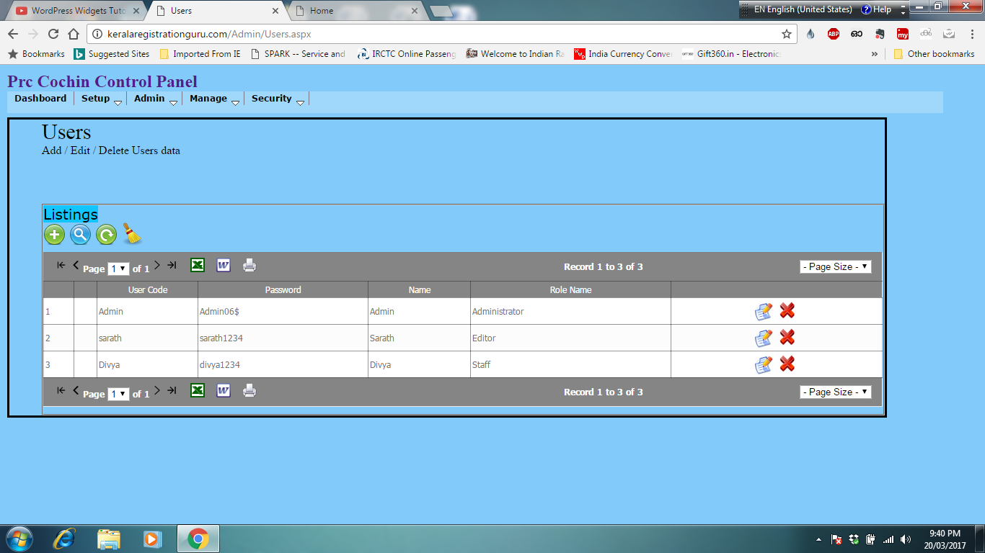

Subscriber Management

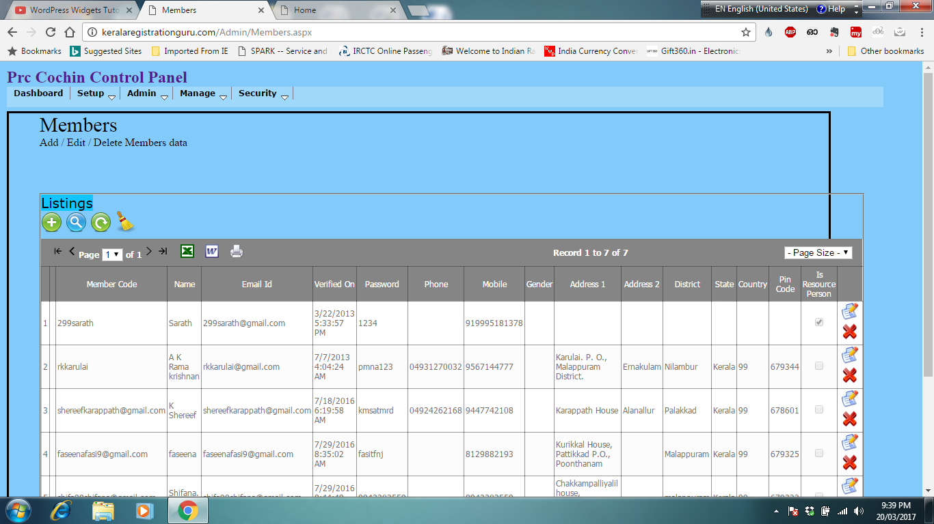

Whole Content/Search Result Display

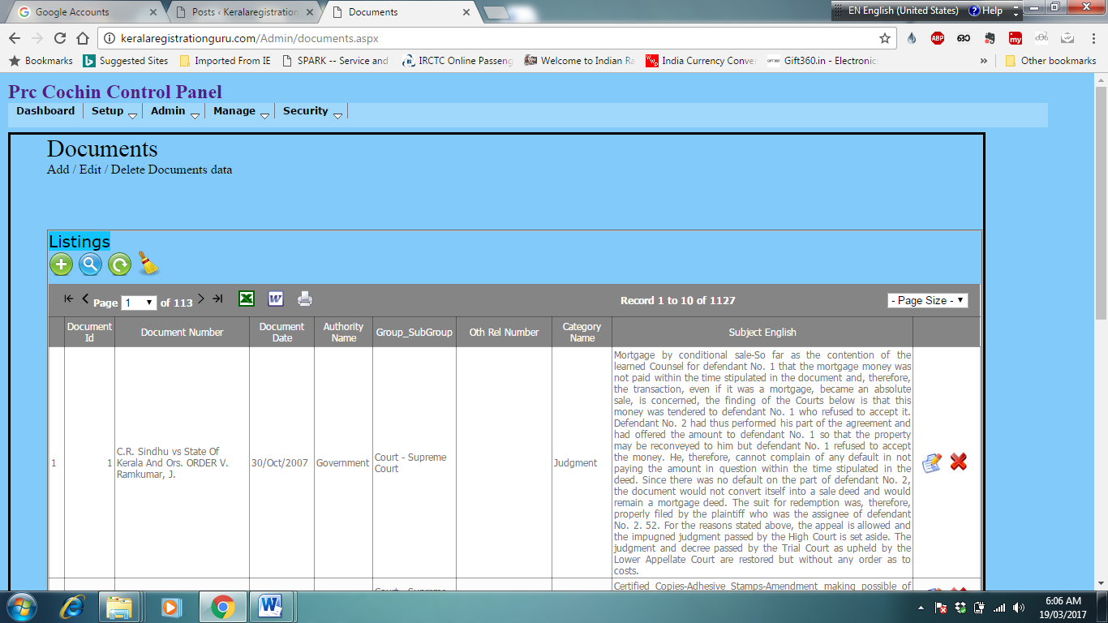

Content Edit window

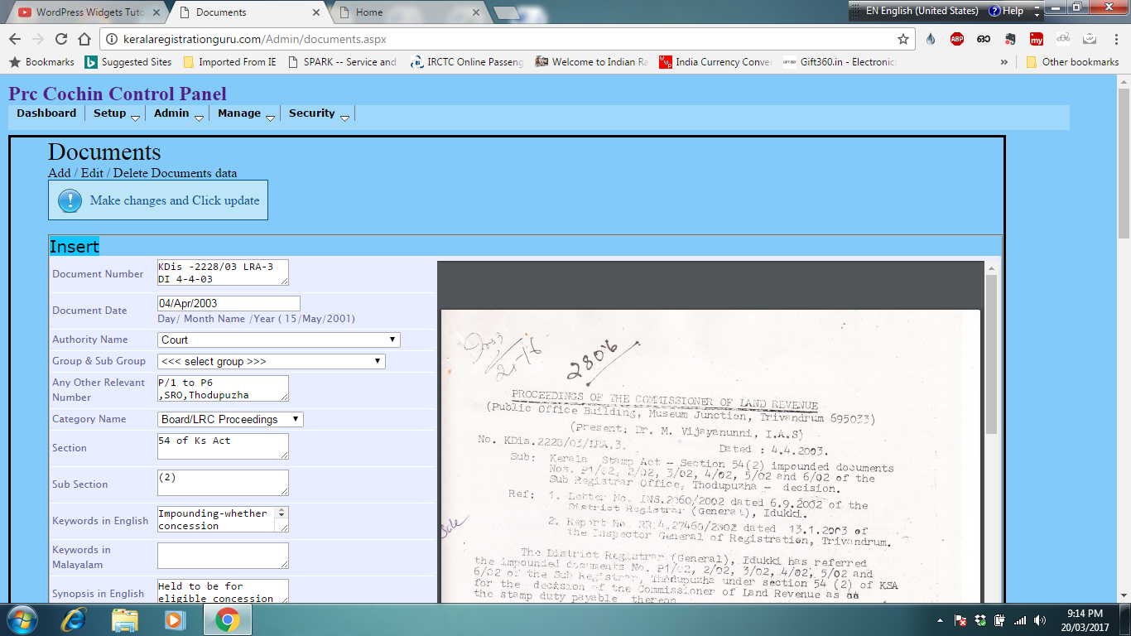

Sign up Sign in Sign out

Let there be security features, captcha, email ID and Mobile verification along with OTP authorization etc. if practicable.